Schedule 'A'
By-law 4157 (2019)(2019)

Rear Yard
Front Yard

Rear Yard
Rear Yard

Max Height: 1.8 m (6')

Max 25%
length of dwelling

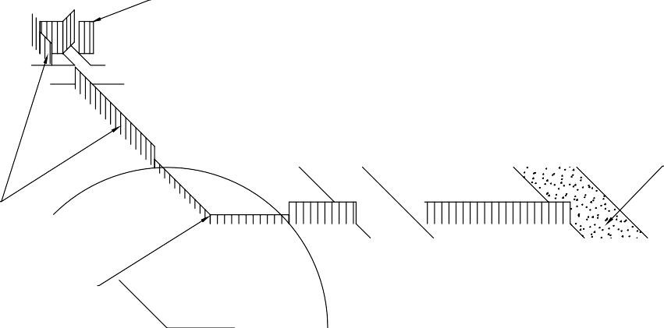
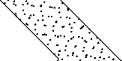
- Corner Lots
Street 'B'
  - Front yards shall be the shortest lot frontage, regardless of the front door
  - Where both lot lines flanking a street are equal, the yard containing the front door is the front yard
- Front Yard
  - Means the yard between the front lot line and the nearest wall of the building
- Rear Yard
  - Means the yard between the rear lot line and

Max Height: 1.22 m (4')
Corner Side Yard
{See through}

Max Height: 0.5 m (1'-8") above street grade level
Radius = 9 m
{See through}

Front Front Yard

Street 'A'
Yard

Property Line
Side Yard

